Inside-Outside Circle
Inside-Outside Circle (also called “Fishbowl”) holds all students accountable for having something to say. The teacher can use this activity as a formative assessment by standing in the center of the circle and listening to the conversations that take place.
Inside-Outside Circle (Kagan, 1994) is a technique that gets students up and moving. It provides a way to get students who normally would not talk to interact with others.
- After students read a section of text or complete a word problem, predict an outcome, etc., the teacher divides the group. Half of the students stand up and form a circle with their backs to the inside of the circle. They are partner “A”. The other half of the students forms a circle facing a partner from the first circle. These students are partner “B”.
- Partner “A” will speak first, quickly summarizing what they learned or explaining their prediction, etc. This takes about a minute.
- Then partner “B” speaks for the same length of time, adding what their partner said. If the teacher stands in the center of the circle, he/she can easily monitor student responses.
- Now it is time to move. Have the students who are partner “A” raise their right hands and then move two people to the right to meet with a new partner. Repeat with partner “B” speaking first.
- For the third move, have all students who are partner “B” raise their right hand and move two people to the right. After they are with a new partner, they continue with partner “A” speaking first.
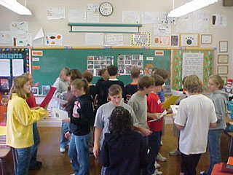
- Depending on the size of the class, teachers may have students move more or fewer times to complete the activity.

