Mind Mapping/Concept Mapping
Mind Maps or Concept Maps are learning tools which help students reinforce knowledge by making connections between different areas and delving in-depth into an area in a visual way.
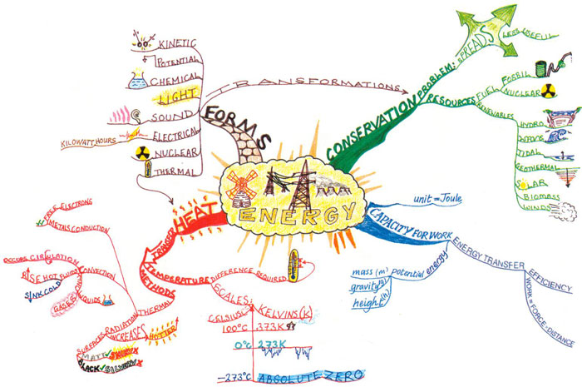

Image taken from
https://blogempire.wordpress.com/category/mind-maps/

Mind Mapping or Concept Mapping can be a great formative assessment to use in order to see what students really understand and exactly how they understand it. It allows a teacher to see what connections students are making between concepts, as well as seeing how their brains are working to organize information--a key skill that many students lack and is not explicitly taught to most students.

Classroom Use
- A Mind Map can be used to give a clear and visual overview of what is going to be covered/taught.
- Mind Maps can show the structure and organization of a topic.
- Students can use a Mind Map to look at while listening to a speaker/teacher. The visual information encourages the audience to engage with the material that is being presented.
- Online Mind Maps can be printed and shared with students. Students can add notes to the map as concepts are developed.

Concept Map Resources:
Concept Maps from Reading Rockets

Concept Maps from Adolescent Literacy

Concept Mapping in the Classroom

