Stoplight Method
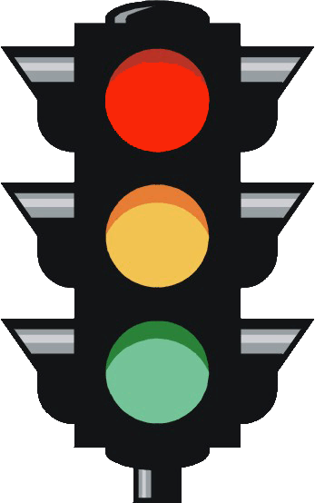
Although the traffic light technique is commonly employed by teachers, it is often used simply as a student self-report and is unreliable as an indicator of learning. With modification, the technique can become a useful classroom tool for encouraging student responsibility for learning.
Materials: Red, yellow, and green sticky dots for each student.
Procedure: First, modify the meaning of the green dot from “I know this.” to “I can teach this to someone else.” At the beginning of the lesson, the students write the lesson learning target in their notebooks/ journals. After the lesson, they place their choice of sticky dot by the learning target. The reds then work with the teacher. The greens teach the yellows, and the yellows make sure the greens really understand.
Test preparation: Traffic light sticky dots may also be used to assist students in understanding what they need to study as they prepare for a test. At the top of each page of their notebooks, the students place a colored sticky dot that corresponds to their level of learning the material on that page. A green dot means, “I can teach this to someone else.” A yellow dot indicates uncertainty. A red dot means the student feels they have not learned the material. As the students study, they skip over the pages marked with green dots, and focus on the material that requires more study.

